Multi-Homed AS

🌐 What Is Multi-Homed AS?
# Source: Chatgpt (GPT‑5 Mini) at [12/15/2025]
A Multi-Homed AS (Autonomous System) is a network that is connected to two or more upstream ISPs (or other external networks) using BGP (Border Gateway Protocol). This setup provides redundancy, reliability, and routing control.

🧠 Simple Definition:
# Source: Chatgpt (GPT‑5 Mini) at [12/15/2025]
A Multi-Homed AS is a network that connects to multiple ISPs using BGP to ensure internet access stays available even if one provider fails.

📦 Key Characteristics
# Source: Chatgpt (GPT‑5 Mini) at [12/15/2025]
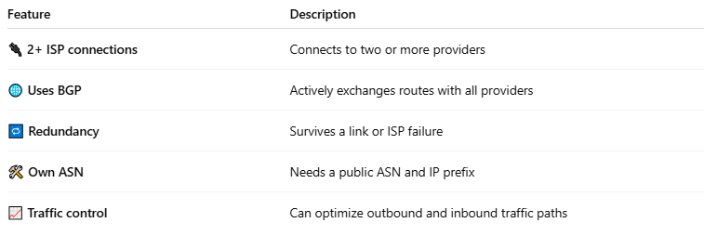

Feature | Description
🔌 2+ ISP connections | Connects to two or more providers
🌐 Uses BGP | Actively exchanges routes with all providers
🔁 Redundancy | Survives a link or ISP failure
🛠️ Own ASN | Needs a public ASN and IP prefix
📈 Traffic control | Can optimize outbound and inbound traffic paths

🖼️ Visual Example
# Source: Chatgpt (GPT‑5 Mini) at [12/15/2025]
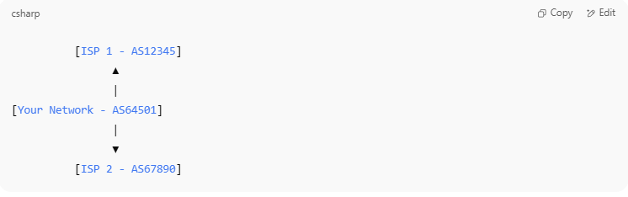
[ISP 1 - AS12345]
▲
|
[Your Network - AS64501]
|
▼
[ISP 2 - AS67890]

🧠 Why Use Multi-Homing?
# Source: Chatgpt (GPT‑5 Mini) at [12/15/2025]
- To avoid downtime if one ISP fails
- To improve routing performance (e.g., shortest path)
- To load balance traffic across providers
- To gain full control over how traffic enters and exits your network

✅ Pros and ❌ Cons
# Source: Chatgpt (GPT‑5 Mini) at [12/15/2025]
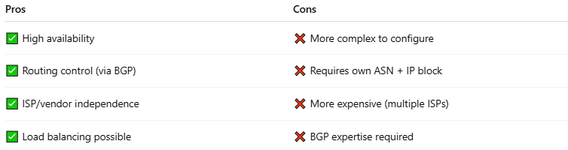
Pros | Cons
✅ High availability | ❌ More complex to configure
✅ Routing control (via BGP) | ❌ Requires own ASN + IP block
✅ ISP/vendor independence | ❌ More expensive (multiple ISPs)
✅ Load balancing possible | ❌ BGP expertise required

🔁 Multi-Homing Types
# Source: Chatgpt (GPT‑5 Mini) at [12/15/2025]
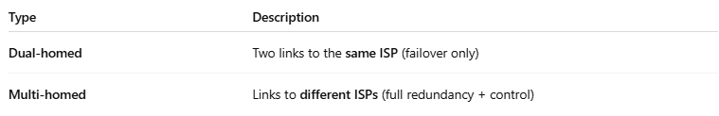
Type | Description
Dual-homed | Two links to the same ISP (failover only)
Multi-homed | Links to different ISPs (full redundancy + control)

🧾 Requirements to Be Multi-Homed
# Source: Chatgpt (GPT‑5 Mini) at [12/15/2025]
- ✅ Own public ASN
- ✅ Own IP address block (IPv4/IPv6)
- ✅ Border routers with BGP support
- ✅ Connections to at least two upstream ASes

🧭 Real-World Use Cases
# Source: Chatgpt (GPT‑5 Mini) at [12/15/2025]
- ISPs
- Large enterprises and data centers
- CDN providers
- Cloud interconnects

✅ Summary
# Source: Chatgpt (GPT‑5 Mini) at [12/15/2025]
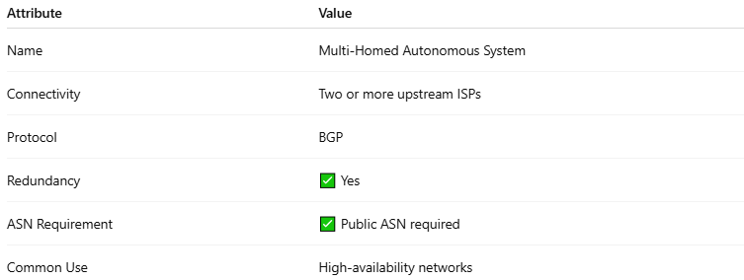
Attribute | Value
Name | Multi-Homed Autonomous System
Connectivity | Two or more upstream ISPs
Protocol | BGP
Redundancy | ✅ Yes
ASN Requirement | ✅ Public ASN required
Common Use | High-availability networks

